17.98: Setting the decrease in internal energy of the water equal to the final gravitational potential energy, 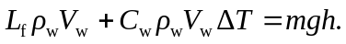 Solving for h, and inserting numbers:
